Please be advised we will be closed on Friday, March 30th to observe Good Friday. We will re-open on Saturday from 8:30am – 2:00pm
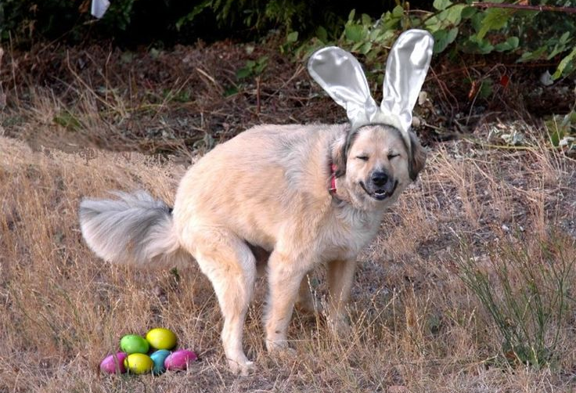
We wish you and your furry friends a wonderful long weekend!
Please call VEC 416-920-2002 if you are having an emergency with your pet.

